ITA0601-MACHINE LEARNING
LAB
1. FIND-S Algorithm
Aim
To implement and demonstrate the FIND-S algorithm in Python to find the most specific hypothesis that is consistent with all positive training examples.
Procedure
- Start the program.
- Import the required libraries.
- Load the training dataset.
- Initialize the hypothesis with the first positive training example.
- Compare the hypothesis with each subsequent positive example.
- If an attribute differs, replace it with ?.
- Ignore negative examples.
- Display the final most specific hypothesis.
- Stop the program.
Program
import csv
data = [
['Sunny', 'Warm', 'Normal', 'Strong', 'Warm', 'Same', 'Yes'],
['Sunny', 'Warm', 'High', 'Strong', 'Warm', 'Same', 'Yes'],
['Rainy', 'Cold', 'High', 'Strong', 'Warm', 'Change', 'No'],
['Sunny', 'Warm', 'High', 'Strong', 'Cool', 'Change', 'Yes']
]
hypothesis = None
for row in data:
if row[-1] == 'Yes':
if hypothesis is None:
hypothesis = row[:-1].copy()
else:
for i in range(len(hypothesis)):
if hypothesis[i] != row[i]:
hypothesis[i] = '?'
print("Training Examples:")
for row in data:
print(row)
print("\nFinal Most Specific Hypothesis:")
print(hypothesis)
Output:
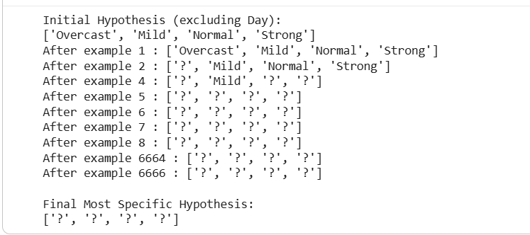
Result
Thus, the FIND-S algorithm was implemented successfully in Python, and the most specific hypothesis consistent with the positive training examples was obtained.

2. Candidate-Elimination Algorithm
Aim
To implement and demonstrate the Candidate-Elimination algorithm in Python using training examples stored in a CSV file and output the set of hypotheses consistent with the training examples.
Procedure
- Start the program.
- Create a CSV file containing the training examples.
- Read the CSV file using Python.
- Initialize the specific boundary $S$with the first positive example and the general boundary $G$with the most general hypothesis.
- For each positive example, minimally generalize $S$and remove inconsistent hypotheses from $G$.
- For each negative example, minimally specialize $G$and remove inconsistent hypotheses from $S$.
- Display the final specific and general boundaries.
- Stop the program.
CSV File: training.csv
Create a file named training.csv with the following data:
csv
Sky,Temperature,Humidity,Wind,Water,Forecast,EnjoySport
Sunny,Warm,Normal,Strong,Warm,Same,Yes
Sunny,Warm,High,Strong,Warm,Same,Yes
Rainy,Cold,High,Strong,Warm,Change,No
Sunny,Warm,High,Strong,Cool,Change,Yes
Python Program
Python
Run
import csv
def more_general_or_equal(h1, h2):
return all(a == '?' or a == b for a, b in zip(h1, h2))
def consistent(h, example):
return more_general_or_equal(h, example)

def min_generalization(s, example):
return [
'?' if a != b else a
for a, b in zip(s, example)
]
def min_specializations(g, example, domains, s):
results = []
for i, value in enumerate(g):
if value == '?':
for item in domains[i]:
if item != example[i]:
h = g.copy()
h[i] = item
if more_general_or_equal(h, s):
results.append(h)
return results
with open('training.csv', newline='') as file:
data = list(csv.reader(file))
attributes = data[0][:-1]
examples = data[1:]
domains = [
sorted(set(row[i] for row in examples))
for i in range(len(attributes))
]

Output:
Example 1: ['Overcast' 'Mild' 'Normal' 'Strong'] | Class: Yes
S = ['Overcast', 'Mild', 'Normal', 'Strong']
G = [['?', '?', '?', '?']]
Example 2: ['Sunny' 'Mild' 'Normal' 'Strong'] | Class: Yes
S = ['?', 'Mild', 'Normal', 'Strong']
G = [['?', '?', '?', '?']]
Example 3: ['Sunny' 'Mild' 'High' 'Weak'] | Class: Yes
S = ['?', 'Mild', '?', '?']
G = [['?', '?', '?', '?']]
Example 4: ['Sunny' 'Cool' 'Normal' 'Strong'] | Class: Yes
S = ['?', '?', '?', '?']
G = [['?', '?', '?', '?']]
Example 5: ['Sunny' 'Mild' 'High' 'Weak'] | Class: Yes
S = ['?', '?', '?', '?']
G = [['?', '?', '?', '?']]
Example 5422: ['Rainy' 'Cool' 'High' 'Weak'] | Class: No
S = ['?', '?', '?', '?']
G = []
Example 5423: ['Overcast' 'Cool' 'High' 'Weak'] | Class: Yes
S = ['?', '?', '?', '?']
G = []
Example 5424: ['Sunny' 'Hot' 'High' 'Strong'] | Class: No
S = ['?', '?', '?', '?']
G = []
Example 5425: ['Sunny' 'Cool' 'Normal' 'Strong'] | Class: Yes
S = ['?', '?', '?', '?']
G = []

======================================
FINAL SPECIFIC BOUNDARY
======================================
['?', '?', '?', '?']
======================================
FINAL GENERAL BOUNDARY
======================================

Result
Thus, the Candidate-Elimination algorithm was implemented successfully in Python using a CSV dataset. The final specific and general boundaries were obtained to represent the hypotheses consistent with the training examples.

3. ID3 Decision Tree Algorithm
Aim
To implement and demonstrate the ID3 Decision Tree algorithm in Python using the Play Tennis dataset and classify a new sample.
Procedure
- Start the program.
- Import the required libraries.
- Upload and load the Play Tennis dataset.
- Calculate the entropy of the target attribute.
- Calculate information gain for each feature.
- Select the feature with the highest information gain.
- Build the decision tree recursively using the ID3 algorithm.
- Display the decision tree as a graphical tree.
- Classify a new sample using the constructed tree.
- Display the predicted class.
- Stop the program.

Program

import pandas as pd
import numpy as np
import matplotlib.pyplot as plt
import math
from google.colab import files

# Load dataset
uploaded = files.upload()
df = pd.read_csv(next(iter(uploaded)))
df.columns = df.columns.str.strip()
df = df.loc[:, ~df.columns.str.contains("^Unnamed", case=False)]

# Identify target column
target = next(
(c for c in df.columns
if c.lower().replace(" ", "") in
["playtennis", "play", "target", "class", "label"]),
df.columns[-1]
)

# Remove serial number columns
for col in list(df.columns):
if col != target and col.lower().strip() in ["day", "id", "index"]:
df = df.drop(columns=col)

df = df.dropna().astype(str).reset_index(drop=True)
features = [c for c in df.columns if c != target]

# Calculate entropy
def entropy(data):
counts = data[target].value_counts()
total = len(data)
return -sum(
(n / total) * math.log2(n / total)
for n in counts
)

# Calculate information gain
def information_gain(data, feature):
total = entropy(data)
weighted = 0

for value, subset in data.groupby(feature):
weighted += len(subset) / len(data) * entropy(subset)

return total - weighted

# Implement ID3
def id3(data, features):
labels = data[target]

if labels.nunique() == 1:
return {"leaf": labels.iloc[0]}

if not features:
return {"leaf": labels.mode()[0]}

gains = {
f: information_gain(data, f)
for f in features
}
best = max(gains, key=gains.get)

node = {
"feature": best,
"majority": labels.mode()[0],
"branches": {}
}

remaining = [f for f in features if f != best]

for value, subset in data.groupby(best):
node["branches"][value] = id3(subset, remaining)

return node

tree = id3(df, features)

# Display tree as text
def print_tree(node, indent=""):
if "leaf" in node:
print(indent + "Predict:", node["leaf"])
return

print(indent + "Feature:", node["feature"])

for value, child in node["branches"].items():
print(indent + " " + str(value) + " -->")
print_tree(child, indent + " ")

print("ID3 Decision Tree:")
print_tree(tree)

# Visualize the actual ID3 tree
positions = {}
leaf_count = [0]
max_depth = [0]

def assign_positions(node, depth=0):
max_depth[0] = max(max_depth[0], depth)

if "leaf" in node:
x = leaf_count[0]
leaf_count[0] += 1
positions[id(node)] = (x, depth)
return x

child_x = [
assign_positions(child, depth + 1)
for child in node["branches"].values()
]

x = sum(child_x) / len(child_x)
positions[id(node)] = (x, depth)
return x

assign_positions(tree)

fig, ax = plt.subplots(
figsize=(max(16, leaf_count[0] * 2.5),
max(9, (max_depth[0] + 1) * 2)),
dpi=150
)

def draw_tree(node):
x, depth = positions[id(node)]
y = -depth

if "leaf" in node:
label = "Class: " + str(node["leaf"])
color = "#B7E4C7"
else:
label = str(node["feature"])
color = "#A9D6F5"

ax.text(
x, y, label,
ha="center", va="center",
fontsize=12, fontweight="bold",
bbox=dict(
boxstyle="round,pad=0.6",
facecolor=color, edgecolor="black"
)
)

if "leaf" not in node:
for value, child in node["branches"].items():
cx, cd = positions[id(child)]
cy = -cd

ax.annotate(
"", xy=(cx, cy + 0.2),
xytext=(x, y - 0.2),
arrowprops=dict(arrowstyle="->", lw=1.5)
)

ax.text(
(x + cx) / 2, (y + cy) / 2,
str(value), ha="center",
fontsize=10,
bbox=dict(facecolor="white", edgecolor="none")
)

draw_tree(child)

draw_tree(tree)
ax.set_title("ID3 Decision Tree - Play Tennis",
fontsize=18, fontweight="bold")
ax.set_xlim(-1, max(leaf_count[0], 1))
ax.set_ylim(-max_depth[0] - 1, 1)
ax.axis("off")
plt.tight_layout()
plt.savefig("ID3_Decision_Tree.png", dpi=300, bbox_inches="tight")
plt.show()

# Classify a new sample
preferred = {
"outlook": "Sunny",
"temperature": "Cool",
"temp": "Cool",
"humidity": "High",
"wind": "Weak"
}

sample = {}
for feature in features:
value = preferred.get(feature.lower())
if value not in df[feature].unique():
value = df[feature].mode()[0]
sample[feature] = value

def predict(node, sample):
while "leaf" not in node:
feature = node["feature"]
value = sample.get(feature, "")

if value in node["branches"]:
node = node["branches"][value]
else:
return node["majority"]

return node["leaf"]

print("\nNew Sample:", sample)
print("Predicted Class:", predict(tree, sample))
print("\nExperiment 3 completed successfully.")
Output
Play Tennis.csv(text/csv) - 204798 bytes, last modified: 10/7/2026 - 100% done
Saving Play Tennis.csv to Play Tennis (1).csv
Dataset loaded successfully!

Dataset:
Outlook Temperature Humidity Wind Play
0 Overcast Mild Normal Strong Yes
1 Sunny Mild Normal Strong Yes
2 Sunny Mild High Weak Yes
3 Sunny Cool Normal Strong Yes
4 Sunny Mild High Weak Yes

Target column: Play

ID3 Decision Tree:
Feature: Outlook
Overcast -->
Feature: Temperature
Cool -->
Predict: Yes
Hot -->
Feature: Humidity
High -->
Feature: Wind
Strong -->
Predict: No
Weak -->
Predict: Yes
Normal -->
Feature: Wind
Strong -->
Predict: Yes
Weak -->
Predict: Yes
Mild -->
Feature: Wind
Strong -->
Feature: Humidity
High -->
Predict: Yes
Normal -->
Predict: Yes
Weak -->
Predict: Yes
Rainy -->
Feature: Temperature
Cool -->
Feature: Humidity
High -->
Feature: Wind
Strong -->
Predict: No
Weak -->
Predict: Yes
Normal -->
Feature: Wind
Strong -->
Predict: Yes
Weak -->
Predict: Yes
Hot -->
Predict: No
Mild -->
Feature: Humidity
High -->
Predict: No
Normal -->
Feature: Wind
Strong -->
Predict: No
Weak -->
Predict: Yes
Sunny -->
Feature: Temperature
Cool -->
Feature: Wind
Strong -->
Feature: Humidity
High -->
Predict: Yes
Normal -->
Predict: Yes
Weak -->
Predict: Yes
Hot -->
Feature: Humidity
High -->
Predict: No
Normal -->
Feature: Wind
Strong -->
Predict: No
Weak -->
Predict: Yes
Mild -->
Feature: Humidity
High -->
Feature: Wind
Strong -->
Predict: No
Weak -->
Predict: Yes
Normal -->
Feature: Wind
Strong -->
Predict: Yes
Weak -->
Predict: Yes

New Sample:
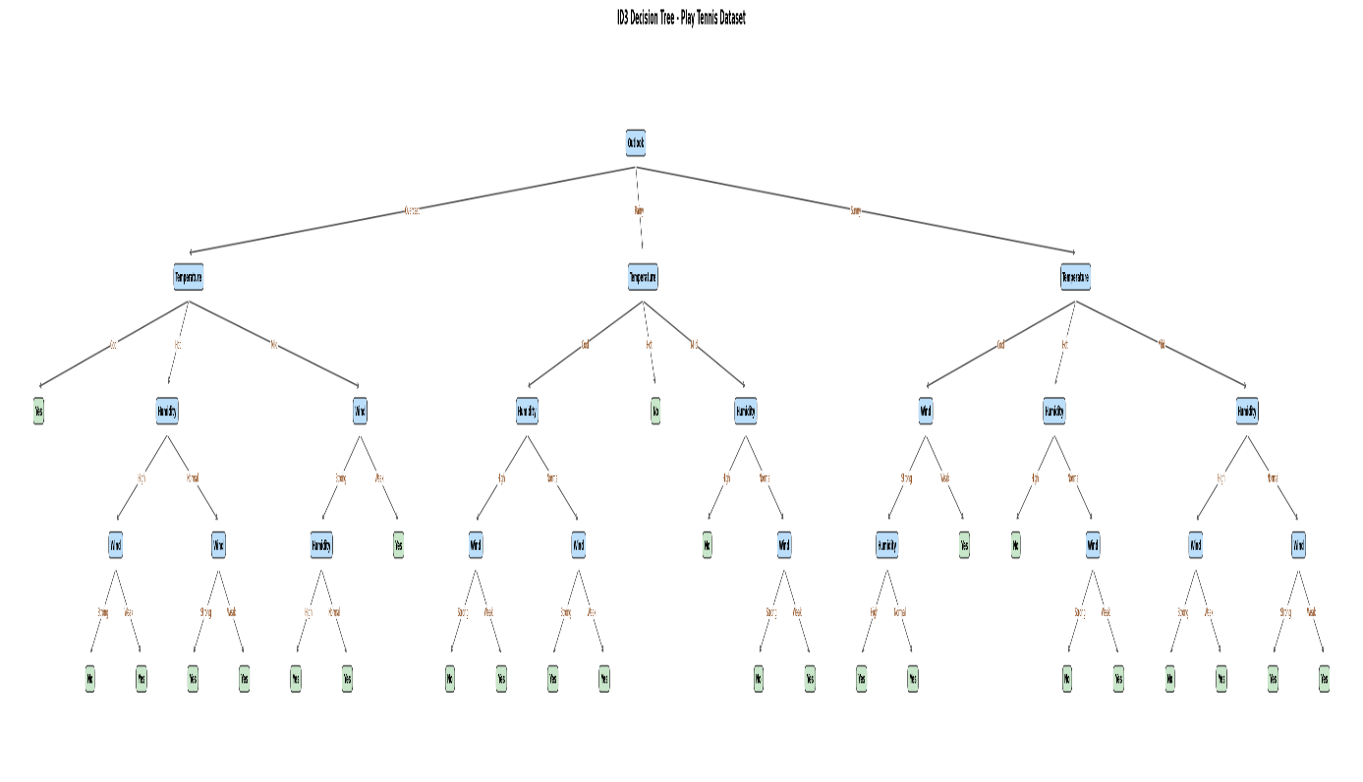
{'Outlook': 'Sunny', 'Temperature': 'Cool', 'Humidity': 'High', 'Wind': 'Weak'}
Predicted class: Yes
Result
Thus, the ID3 Decision Tree algorithm was implemented successfully in Python using the Play Tennis dataset. The decision tree was constructed using information gain, and a new sample was classified successfully.
4. Artificial Neural Network Using Backpropagation
Aim
To build an Artificial Neural Network using the Backpropagation algorithm in Python and test it using the Play Tennis dataset.
Procedure
- Start the program.
- Import the required libraries.
- Upload and load the Play Tennis dataset.
- Encode the categorical input attributes into numerical values.
- Divide the dataset into training and testing sets.
- Initialize the neural network weights and biases.
- Perform forward propagation using the sigmoid activation function.
- Calculate the output error and propagate it backward.
- Update the weights and biases using gradient descent.
- Test the trained neural network and calculate its accuracy.
- Predict the class of a new sample.
- Stop the program.
Program

# LARGE AND CLEAR ANN OUTPUT - EXPERIMENT 4

import matplotlib.pyplot as plt
import numpy as np
from sklearn.metrics import accuracy_score, confusion_matrix

# STEP 1: Plot training loss in large size
plt.figure(figsize=(12, 6), dpi=150)
plt.plot(loss_history, linewidth=2)
plt.title("ANN Training Loss using Backpropagation", fontsize=18)
plt.xlabel("Epoch", fontsize=14)
plt.ylabel("Binary Cross-Entropy Loss", fontsize=14)
plt.xticks(fontsize=11)
plt.yticks(fontsize=11)
plt.grid(True)
plt.tight_layout()
plt.savefig("ANN_Training_Loss.png", dpi=300, bbox_inches="tight")
plt.show()

# STEP 2: Test the trained ANN
hidden_test = sigmoid(X_test @ W1 + b1)
output_test = sigmoid(hidden_test @ W2 + b2)
predicted_numeric = (output_test >= 0.5).astype(int).ravel()

actual_numeric = y_test.astype(int).ravel()
accuracy = accuracy_score(actual_numeric, predicted_numeric)

actual_labels = np.array(class_names)[actual_numeric]
predicted_labels = np.array(class_names)[predicted_numeric]

print("ARTIFICIAL NEURAL NETWORK - BACKPROPAGATION")
print("-------------------------------------------")
print("Training samples:", len(X_train))
print("Testing samples:", len(X_test))
print("Actual labels:", actual_labels)
print("Predicted labels:", predicted_labels)
print("Test Accuracy: {:.2f}%".format(accuracy * 100))

# STEP 3: Display a large confusion matrix
cm = confusion_matrix(actual_numeric, predicted_numeric, labels=[0, 1])

fig, ax = plt.subplots(figsize=(8, 6), dpi=150)
image = ax.imshow(cm, cmap="Blues")

ax.set_title("ANN Confusion Matrix", fontsize=18)
ax.set_xlabel("Predicted Class", fontsize=14)
ax.set_ylabel("Actual Class", fontsize=14)
ax.set_xticks([0, 1])
ax.set_yticks([0, 1])
ax.set_xticklabels(class_names, fontsize=12)
ax.set_yticklabels(class_names, fontsize=12)

for i in range(2):
for j in range(2):
ax.text(
j, i, str(cm[i, j]),
ha="center", va="center",
fontsize=18, fontweight="bold"
)

fig.colorbar(image, ax=ax)
plt.tight_layout()
plt.savefig("ANN_Confusion_Matrix.png", dpi=300, bbox_inches="tight")
plt.show()

# STEP 4: Predict a new sample
preferred_values = {
"outlook": "Sunny",
"temperature": "Cool",
"temp": "Cool",
"humidity": "High",
"wind": "Weak"
}

new_sample = {}

for feature in features:
value = preferred_values.get(feature.lower())
if value not in df[feature].unique():
value = df[feature].mode()[0]
new_sample[feature] = value

new_df = pd.DataFrame([new_sample])
new_encoded = pd.get_dummies(new_df, dtype=float)
new_encoded = new_encoded.reindex(columns=X_df.columns, fill_value=0)

new_scaled = scaler.transform(new_encoded.to_numpy(dtype=float))
hidden_new = sigmoid(new_scaled @ W1 + b1)
output_new = sigmoid(hidden_new @ W2 + b2)

predicted_class = class_names[int(output_new[0, 0] >= 0.5)]

print("\nNew Sample:", new_sample)
print("Output probability: {:.4f}".format(output_new[0, 0]))
print("Predicted class:", predicted_class)
print("\nExperiment 4 completed successfully!")
Output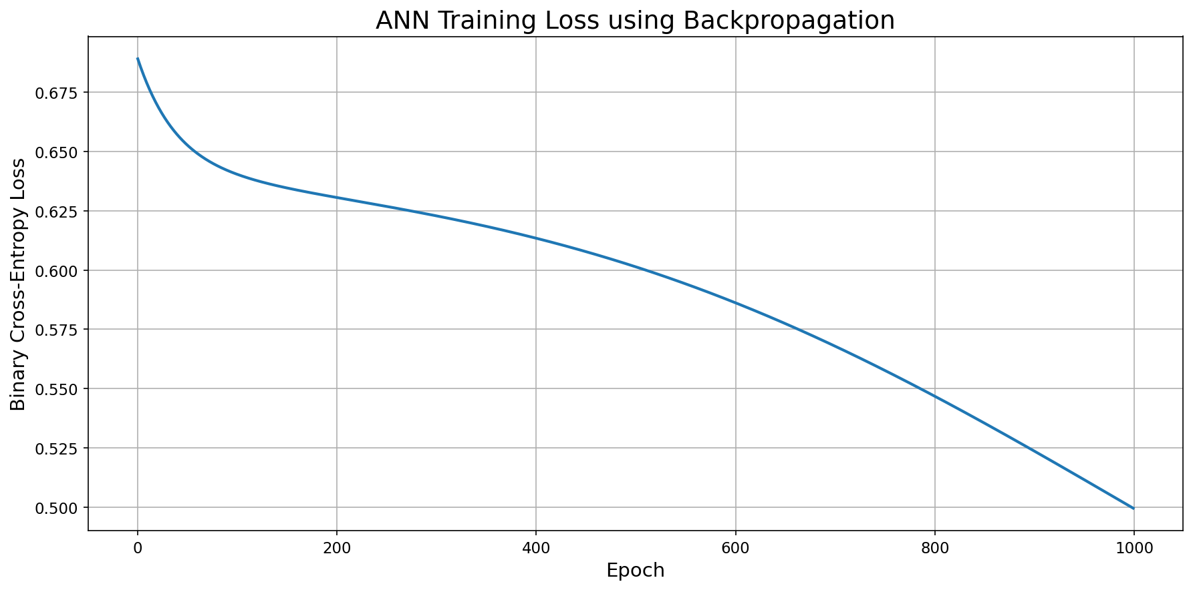
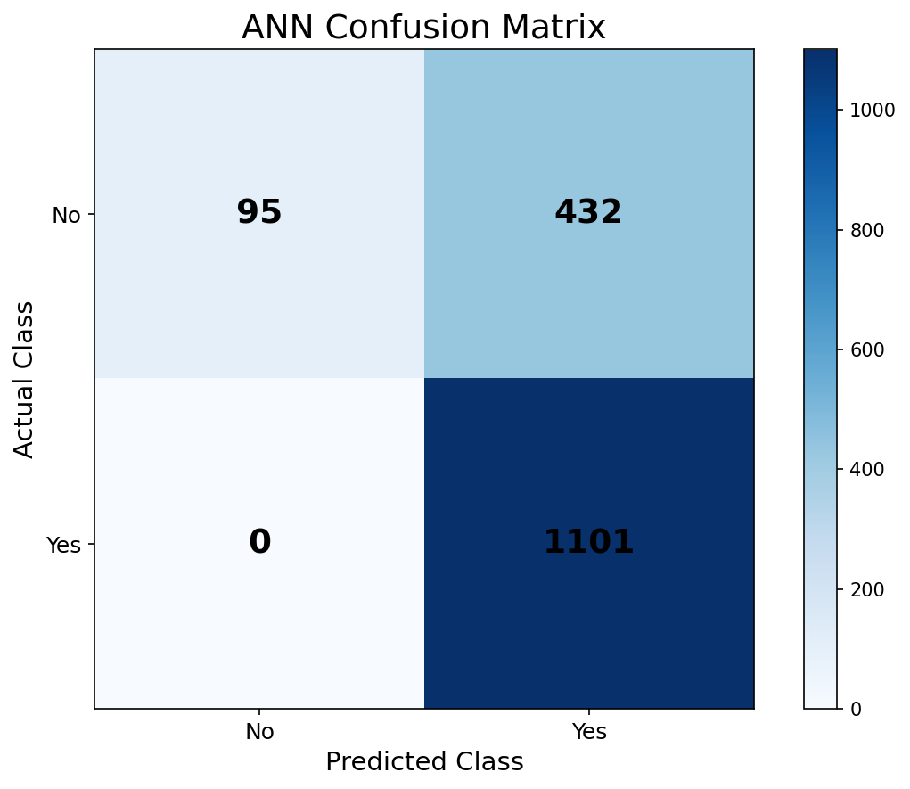
Result
Thus, the Artificial Neural Network was implemented successfully using the Backpropagation algorithm. The network was trained and tested using the Play Tennis dataset, and its classification accuracy was calculated successfully.

16.Compare Different Classification Algorithms and Evaluate Their Performance
Aim
To compare different classification algorithms and evaluate their performance using accuracy, confusion matrix, and classification report.
Algorithms Used
- Logistic Regression
- Decision Tree
- K-Nearest Neighbors (KNN)
- Support Vector Machine (SVM)
- Random Forest
Comparison of Classification Algorithms
# Import libraries
import pandas as pd
import matplotlib.pyplot as plt
from sklearn.datasets import load_iris
from sklearn.model_selection import train_test_split
from sklearn.preprocessing import StandardScaler
from sklearn.pipeline import make_pipeline
from sklearn.linear_model import LogisticRegression
from sklearn.tree import DecisionTreeClassifier
from sklearn.neighbors import KNeighborsClassifier
from sklearn.svm import SVC
from sklearn.ensemble import RandomForestClassifier
from sklearn.metrics import accuracy_score, classification_report, confusion_matrix
# Load Iris dataset
iris = load_iris()
X = iris.data
y = iris.target
# Split dataset
X_train, X_test, y_train, y_test = train_test_split(
X, y, test_size=0.2, random_state=42, stratify=y
)
# Define classification algorithms
models = {
"Logistic Regression": make_pipeline(
StandardScaler(),
LogisticRegression(max_iter=1000)
),
"Decision Tree": DecisionTreeClassifier(random_state=42),
"KNN": make_pipeline(
StandardScaler(),
KNeighborsClassifier(n_neighbors=5)
),
"SVM": make_pipeline(
StandardScaler(),
SVC()
),
"Random Forest": RandomForestClassifier(
n_estimators=100,
random_state=42
)
}
# Store results
results = {}
# Train and evaluate each model
for name, model in models.items():
model.fit(X_train, y_train)
y_pred = model.predict(X_test)
accuracy = accuracy_score(y_test, y_pred)
results[name] = accuracy
print("\n" + "=" * 50)
print(name)
print("=" * 50)
print("Accuracy:", round(accuracy * 100, 2), "%")
print("\nClassification Report:")
print(classification_report(
y_test,
y_pred,
target_names=iris.target_names
))
print("Confusion Matrix:")
print(confusion_matrix(y_test, y_pred))
# Display comparison
print("\n\nAlgorithm Performance Comparison")
print("-" * 40)
for name, accuracy in results.items():
print(f"{name:25s}: {accuracy * 100:.2f}%")
# Plot accuracy comparison
plt.figure(figsize=(9, 5))
plt.bar(results.keys(), results.values())
plt.xlabel("Classification Algorithm")
plt.ylabel("Accuracy")
plt.title("Comparison of Classification Algorithms")
plt.xticks(rotation=30)
plt.ylim(0, 1.1)
plt.show()
Output:
Accuracy: 90.0 %
Classification Report:
precision recall f1-score support
setosa 1.00 1.00 1.00 10
versicolor 0.82 0.90 0.86 10
virginica 0.89 0.80 0.84 10
accuracy 0.90 30
macro avg 0.90 0.90 0.90 30
weighted avg 0.90 0.90 0.90 30

Confusion Matrix:
[[10 0 0]
[ 0 9 1]
[ 0 2 8]]
Algorithm Performance Comparison
----------------------------------------
Logistic Regression : 93.33%
Decision Tree : 93.33%
KNN : 93.33%
SVM : 96.67%
Random Forest : 90.00%
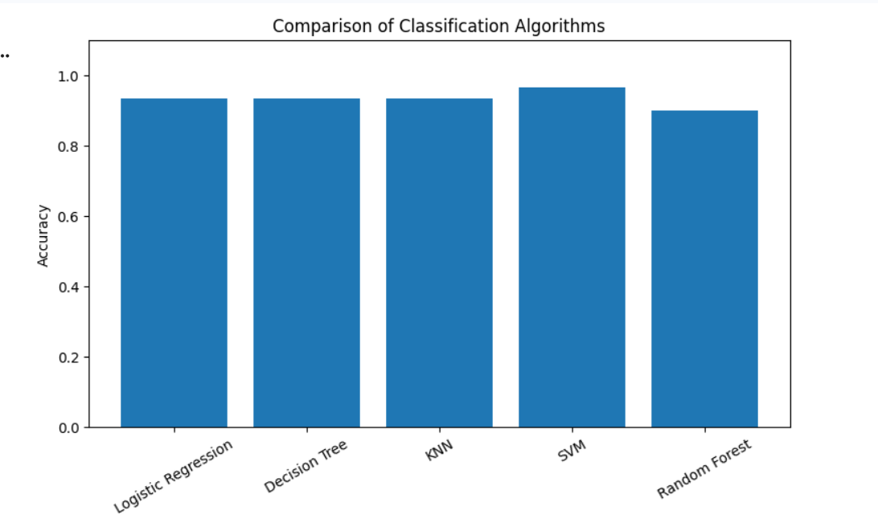
Result
The different classification algorithms were successfully implemented and their performances were compared using accuracy, classification reports, and confusion matrices.

17. Mobile Price Prediction Using Machine Learning
Aim
To implement Mobile Price Prediction using an appropriate machine learning algorithm.
Here, Random Forest Classifier is used to predict the mobile price range.
Code
# Question 17: Mobile Price Prediction

# Import libraries
import pandas as pd
import matplotlib.pyplot as plt

from sklearn.model_selection import train_test_split
from sklearn.ensemble import RandomForestClassifier
from sklearn.metrics import accuracy_score, classification_report, confusion_matrix

# Download Mobile Price dataset
url = "https://raw.githubusercontent.com/selva86/datasets/master/mobile_price_classification.csv"

try:
df = pd.read_csv(url)
except:
print("Dataset could not be downloaded.")

# If the above dataset is unavailable, create a sample dataset
if 'df' not in locals():
data = {
'battery_power': [842, 1021, 563, 615, 1821, 1859, 1568, 1573,
1965, 1411, 1036, 775, 1821, 1078, 1375],
'ram': [2549, 2631, 2603, 2769, 1411, 1414, 2216, 2250,
2734, 2602, 1993, 2865, 1704, 2346, 1452],
'px_height': [20, 905, 1263, 1216, 1208, 1004, 1020, 1080,
1260, 1125, 775, 1210, 1030, 1150, 900],
'px_width': [756, 1988, 1716, 1786, 1212, 1987, 1654, 1965,
1850, 1948, 1536, 1890, 1650, 1780, 1500],
'price_range': [1, 2, 2, 2, 1, 1, 2, 2, 3, 2, 1, 3, 2, 2, 1]
}

df = pd.DataFrame(data)

print("First 5 records:")
print(df.head())

print("\nDataset Shape:", df.shape)

# Select features
features = [
'battery_power',
'ram',
'px_height',
'px_width'
]

X = df[features]
y = df['price_range']

# Split dataset
X_train, X_test, y_train, y_test = train_test_split(
X,
y,
test_size=0.2,
random_state=42
)

# Create Random Forest model
model = RandomForestClassifier(
n_estimators=100,
random_state=42
)

# Train model
model.fit(X_train, y_train)

# Predict
y_pred = model.predict(X_test)

# Evaluate
accuracy = accuracy_score(y_test, y_pred)

print("\nModel Accuracy:")
print(round(accuracy * 100, 2), "%")

print("\nClassification Report:")
print(classification_report(y_test, y_pred))

print("\nConfusion Matrix:")
print(confusion_matrix(y_test, y_pred))

# Predict price range for a new mobile
new_mobile = [[1500, 2500, 800, 1800]]

prediction = model.predict(new_mobile)

print("\nNew Mobile Details:")
print("Battery Power = 1500")
print("RAM = 2500 MB")
print("Pixel Height = 800")
print("Pixel Width = 1800")

print("\nPredicted Price Range:", prediction[0])

# Price range meaning
price_ranges = {
0: "Low Cost",
1: "Medium Cost",
2: "High Cost",
3: "Very High Cost"
}

print("Category:", price_ranges.get(
prediction[0],
"Unknown"
))

Output:
Dataset could not be downloaded.
First 5 records:
battery_power ram px_height px_width price_range
0 842 2549 20 756 1
1 1021 2631 905 1988 2
2 563 2603 1263 1716 2
3 615 2769 1216 1786 2
4 1821 1411 1208 1212 1
Dataset Shape: (15, 5)
Model Accuracy:
33.33 %
Classification Report:
precision recall f1-score support

1 0.00 0.00 0.00 1
2 0.33 1.00 0.50 1
3 0.00 0.00 0.00 1

accuracy 0.33 3
macro avg 0.11 0.33 0.17 3
weighted avg 0.11 0.33 0.17 3
Confusion Matrix:
[[0 1 0]
[0 1 0]
[0 1 0]]
New Mobile Details:
Battery Power = 1500
RAM = 2500 MB
Pixel Height = 800
Pixel Width = 1800
Predicted Price Range: 2
Category: High Cost
Result
The Random Forest algorithm was successfully implemented to predict the price range of a mobile phone based on its features.

18. Perceptron-Based IRIS Classification
Aim
To implement Iris flower classification using the Perceptron machine learning algorithm.
Google Colab Code
# Question 18: Perceptron Based IRIS Classification

# Import libraries
import pandas as pd
import matplotlib.pyplot as plt

from sklearn.datasets import load_iris
from sklearn.model_selection import train_test_split
from sklearn.preprocessing import StandardScaler
from sklearn.linear_model import Perceptron

from sklearn.metrics import accuracy_score
from sklearn.metrics import classification_report
from sklearn.metrics import confusion_matrix

# Load Iris dataset
iris = load_iris()

X = iris.data
y = iris.target

# Display dataset
print("Feature Names:")
print(iris.feature_names)

print("\nTarget Names:")
print(iris.target_names)

print("\nFirst 5 samples:")
print(X[:5])

# Split dataset
X_train, X_test, y_train, y_test = train_test_split(
X,
y,
test_size=0.2,
random_state=42,
stratify=y
)

# Feature scaling
scaler = StandardScaler()

X_train = scaler.fit_transform(X_train)
X_test = scaler.transform(X_test)

# Create Perceptron model
model = Perceptron(
max_iter=1000,
eta0=0.1,
random_state=42
)

# Train model
model.fit(X_train, y_train)

# Prediction
y_pred = model.predict(X_test)

# Calculate accuracy
accuracy = accuracy_score(y_test, y_pred)

print("\nPerceptron Accuracy:")
print(round(accuracy * 100, 2), "%")

# Classification report
print("\nClassification Report:")
print(classification_report(
y_test,
y_pred,
target_names=iris.target_names
))

# Confusion matrix
print("\nConfusion Matrix:")
print(confusion_matrix(y_test, y_pred))

# Predict a new flower
new_flower = [[5.1, 3.5, 1.4, 0.2]]

new_flower_scaled = scaler.transform(new_flower)

prediction = model.predict(new_flower_scaled)

print("\nNew Flower Measurements:")
print(new_flower)

print("\nPredicted Flower:")
print(iris.target_names[prediction[0]])

# Display accuracy
plt.figure(figsize=(6, 4))

plt.bar(
["Perceptron"],
[accuracy]
)

plt.ylabel("Accuracy")
plt.title("Perceptron Iris Classification Accuracy")
plt.ylim(0, 1.1)

plt.show()

Output:
Feature Names:
['sepal length (cm)', 'sepal width (cm)', 'petal length (cm)', 'petal width (cm)']
Target Names:
['setosa' 'versicolor' 'virginica']

First 5 samples:
[[5.1 3.5 1.4 0.2]
[4.9 3. 1.4 0.2]
[4.7 3.2 1.3 0.2]
[4.6 3.1 1.5 0.2]
[5. 3.6 1.4 0.2]]
Perceptron Accuracy:
86.67 %
Classification Report:
precision recall f1-score support

setosa 1.00 1.00 1.00 10
versicolor 0.88 0.70 0.78 10
virginica 0.75 0.90 0.82 10

accuracy 0.87 30
macro avg 0.88 0.87 0.87 30
weighted avg 0.88 0.87 0.87 30
Confusion Matrix:
[[10 0 0]
[ 0 7 3]
[ 0 1 9]]
New Flower Measurements:
[[5.1, 3.5, 1.4, 0.2]]
Predicted Flower:
setosa
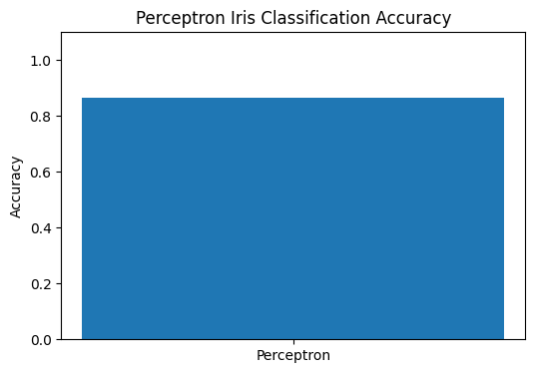
Result
The Perceptron algorithm was successfully implemented for Iris classification. The model classified the Iris flowers into Setosa, Versicolor, and Virginica and its performance was evaluated using accuracy, classification report, and confusion matrix.

